

**BSc (Hons) in Information Technology**

**Software Engineering – Year 3**

**Lab sheet 04**

**LL**

**Lab sheet 04**

**Semester 2, 2021**

**IT3050 – User Experience Engineering**



**User Experience Engineering**

**Sketches, Wireframes and Paper prototypes**

Lab Sheet 06

Group ID : 2021S1_JUNE_WD_04

**Group Member Details**

|  |  |
| --- | --- |
| Student ID | Student Name |
| IT19382036 | L.S Gamage |
| IT19176116 | T. M. L Bambarandage |
| IT19989242 | Anjali W. M. S |



**Version 01**

Loading Page On boding page 01 On boding page 02

 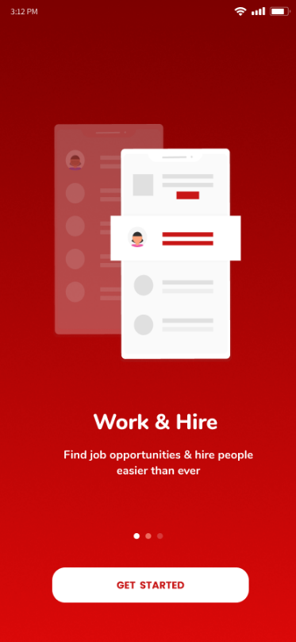 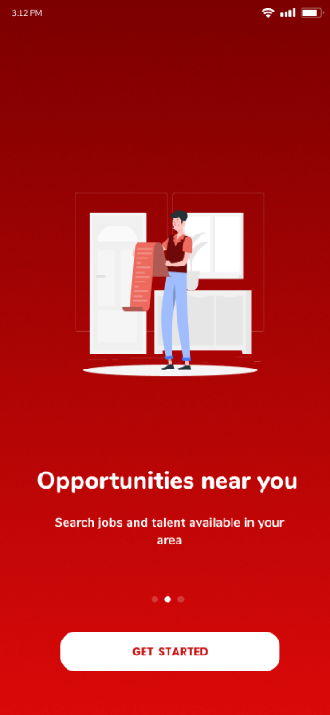

On boding page 03 Home (Job Provider) Home (Job Seeker)

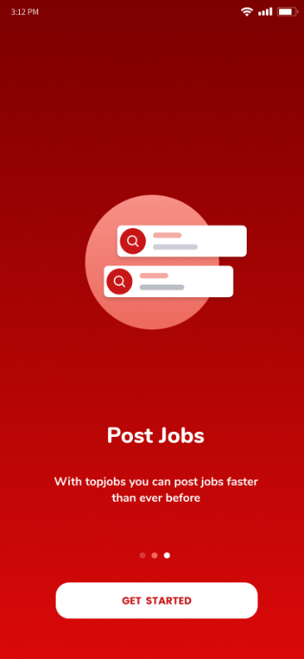 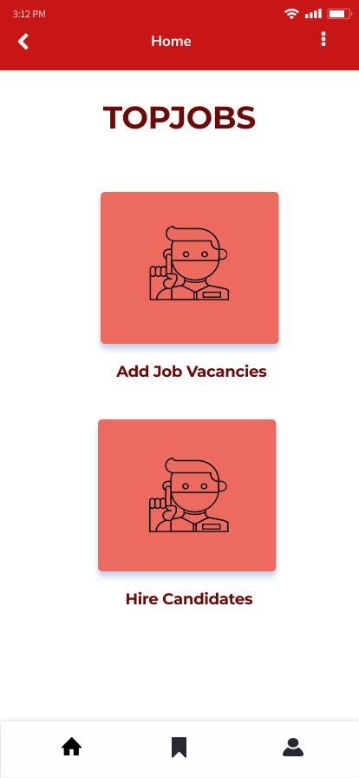 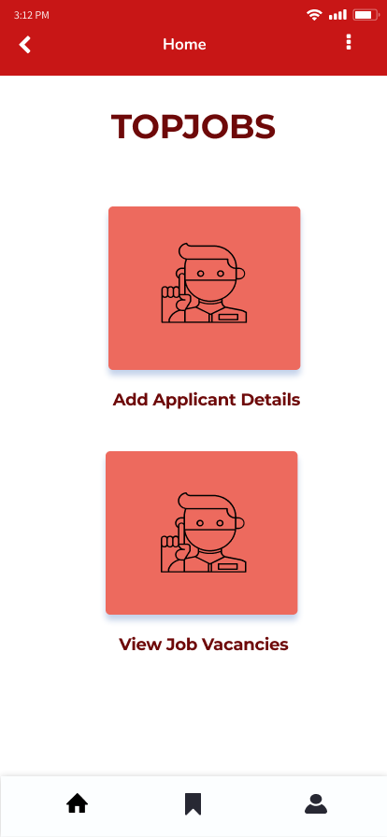

**User Management and Profile** ( IT19176116 - T. M. L Bambarandage)

Home Page Sign In / Sign Up(Job Seeker) Sign In / Sign Up(Job provider)

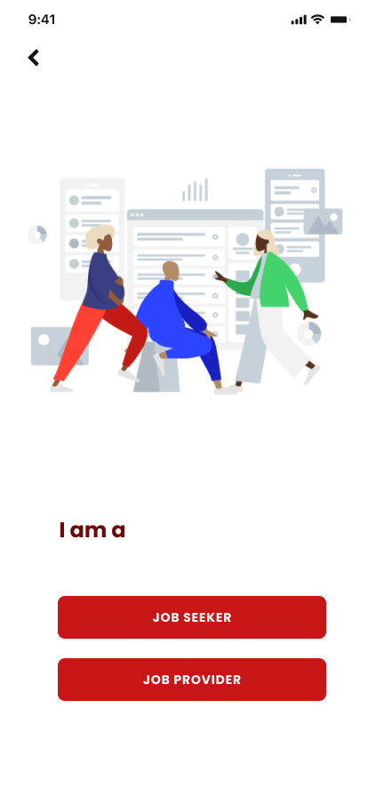 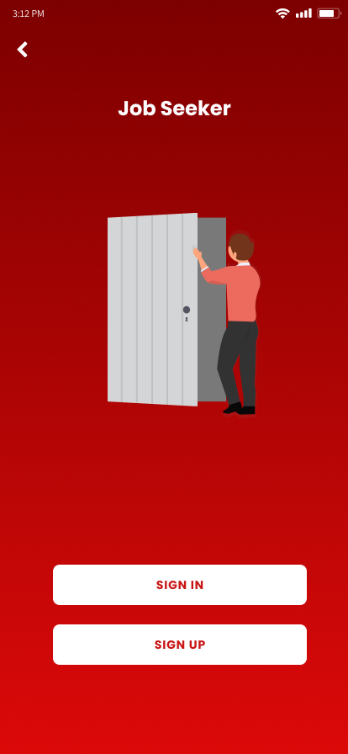 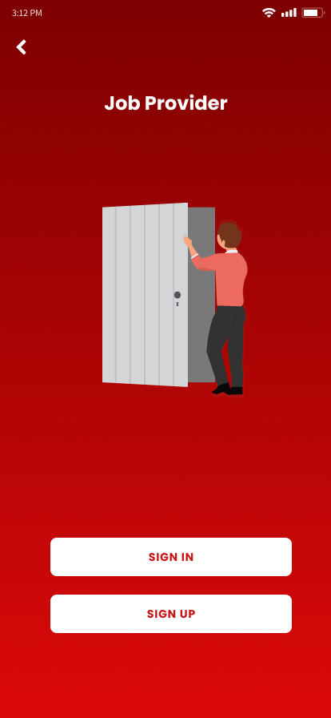

Sign Up (Job Seeker) Sign Up (Job Provider) Sign In (Job Provider)

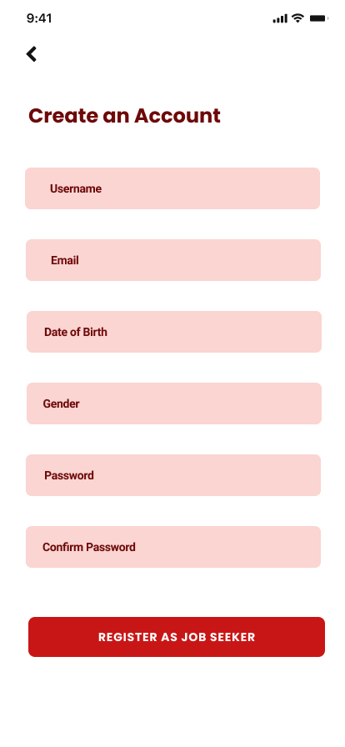 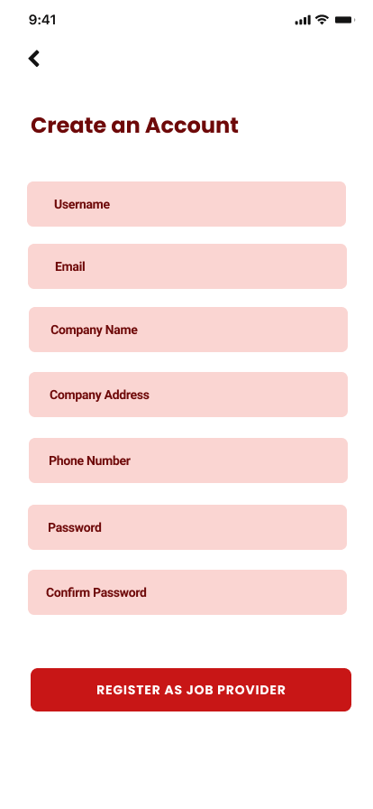 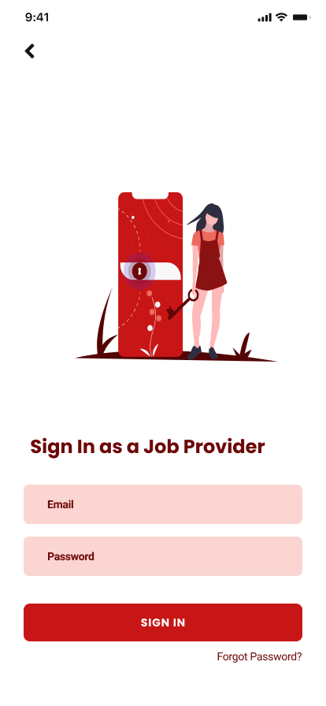

Sign In (Job Seeker) Profile (Job Seeker) profile (Job Provider)

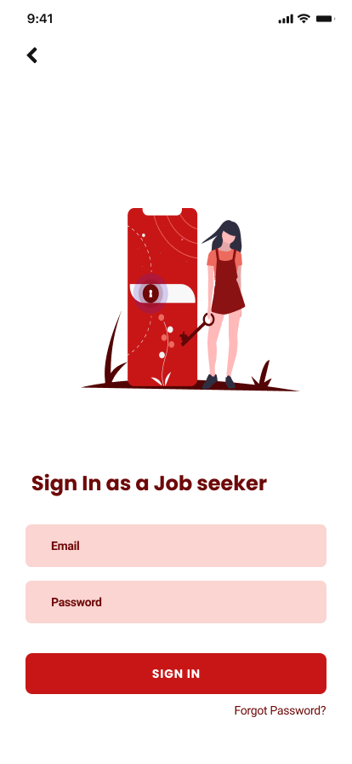 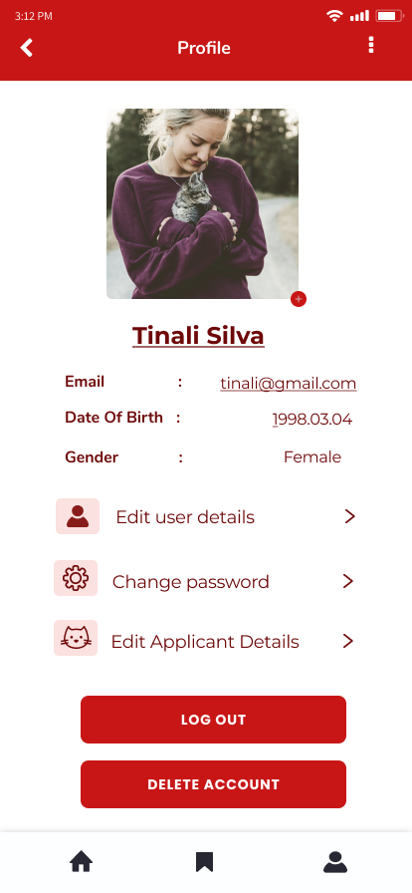 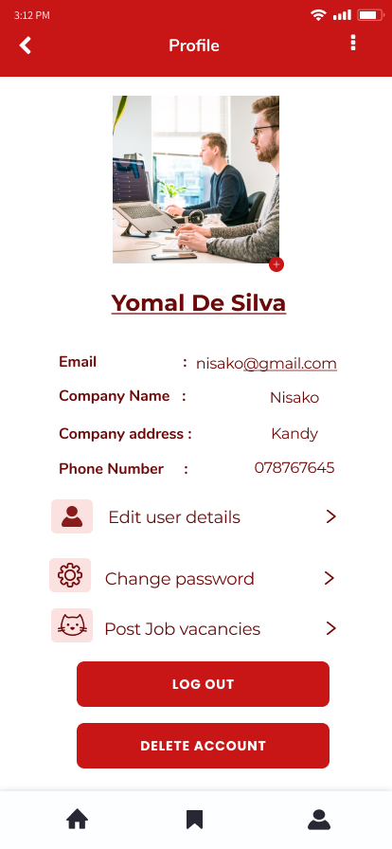

Edit Profile (Job Seeker) Edit Profile (Job Provider) Change Password

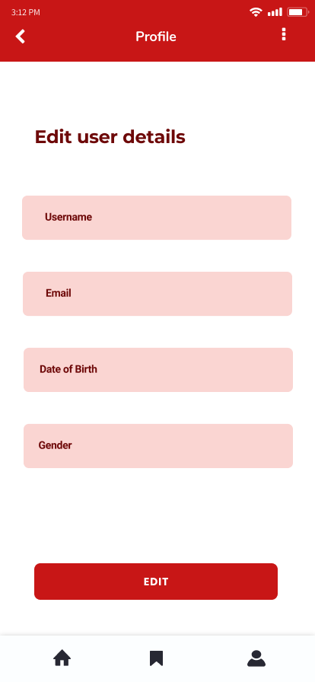 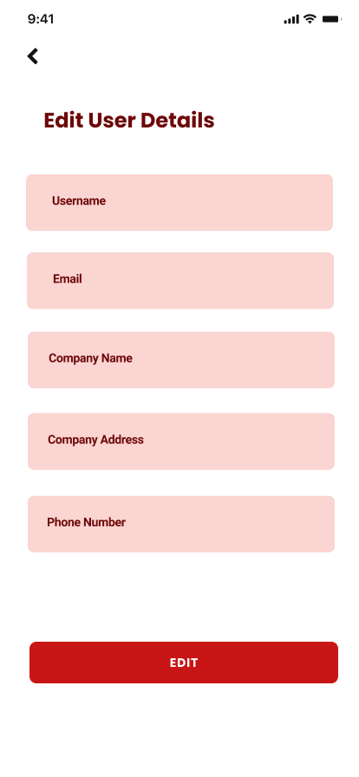 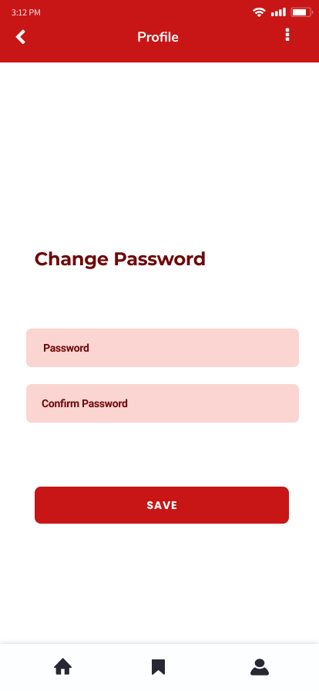

Reset Password Forgot passwoord

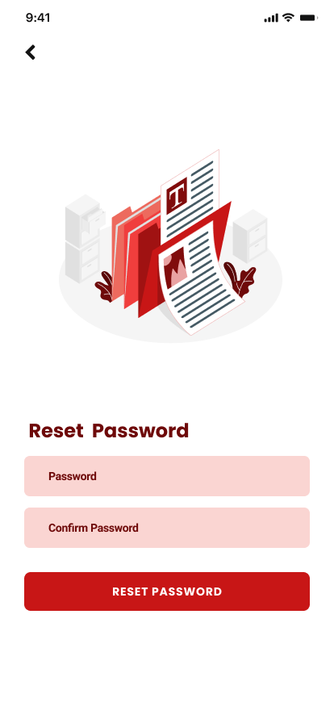 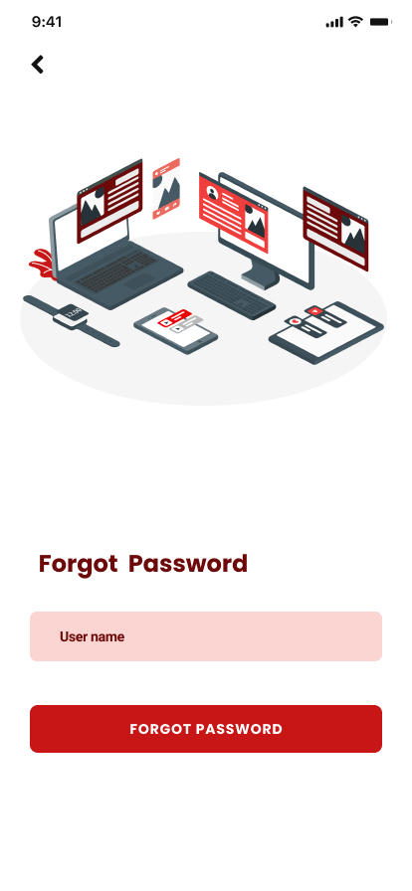

**Post job vacancies.** ( IT19382036 - L.S Gamage )

Job categories View Job Vacancies View Job Vacancies

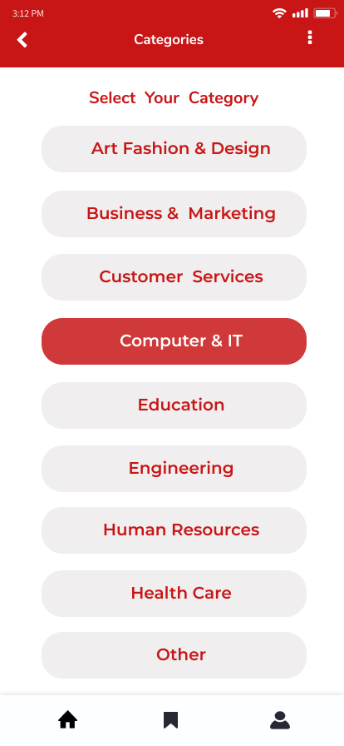 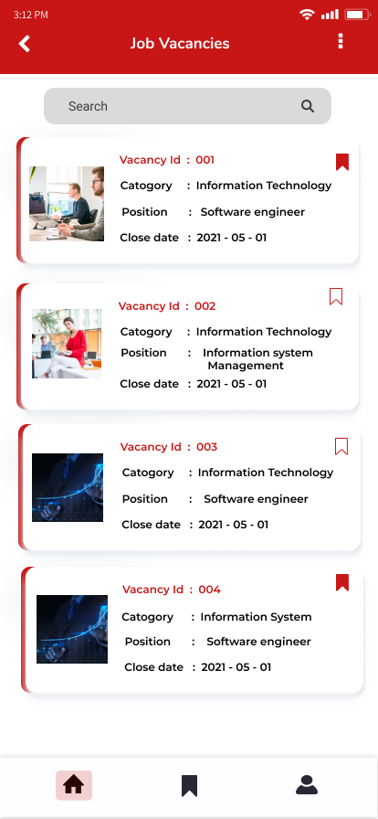 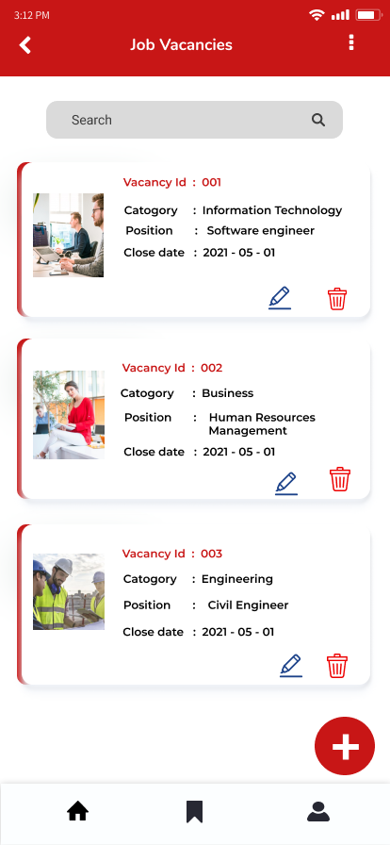

Add Job Details Edit Job Vacancy Delete Job Vacancy

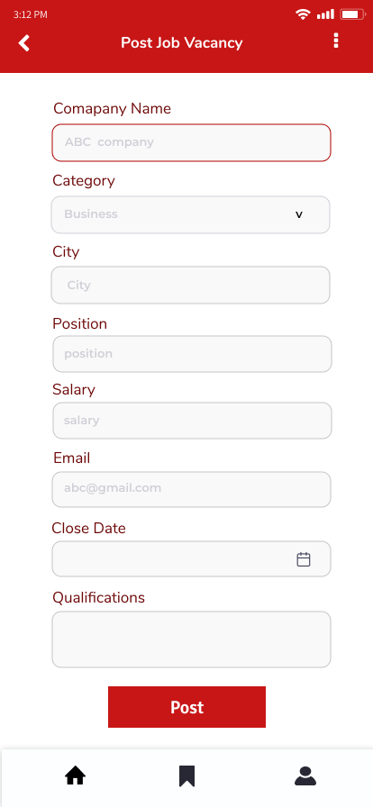 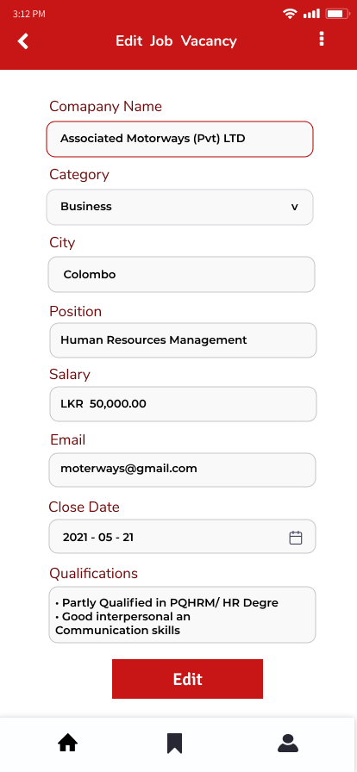 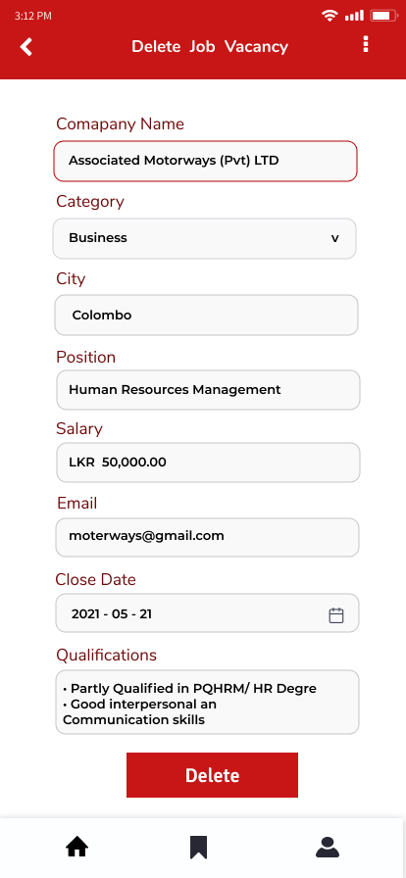

View vacancy Details Favorite Job List

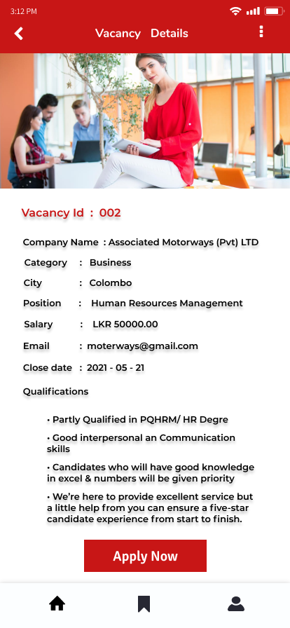 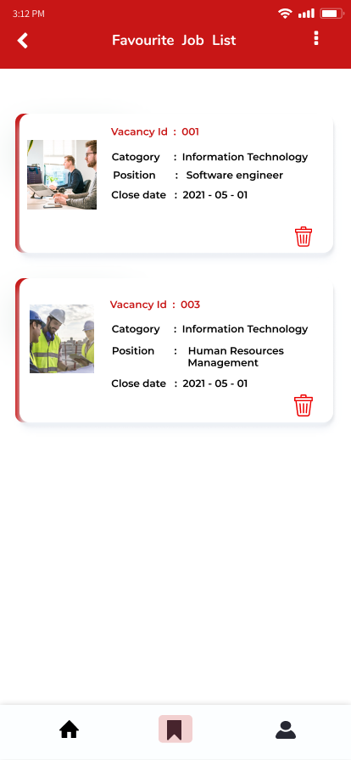

**Manage candidate details and apply for jobs.** (IT19989242 - Anjali W. M. S)

View All Candidates View All Candidates Add Candidate Details

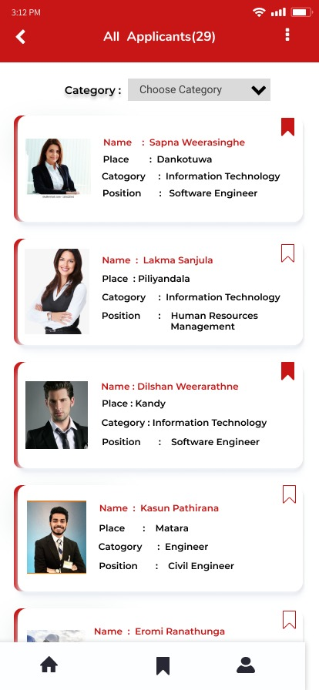 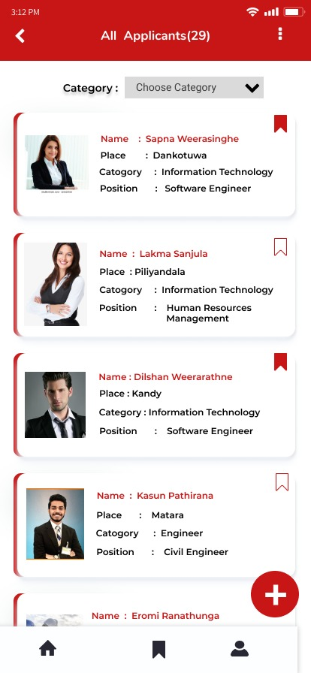 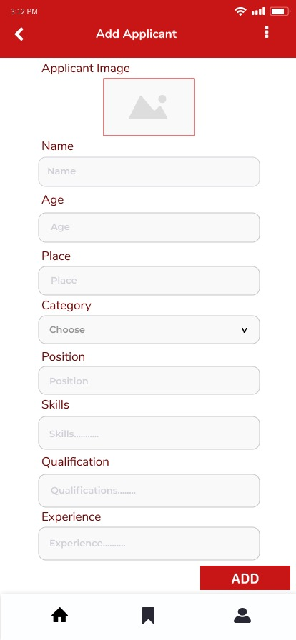

View Application Details Edit Details Delete Details

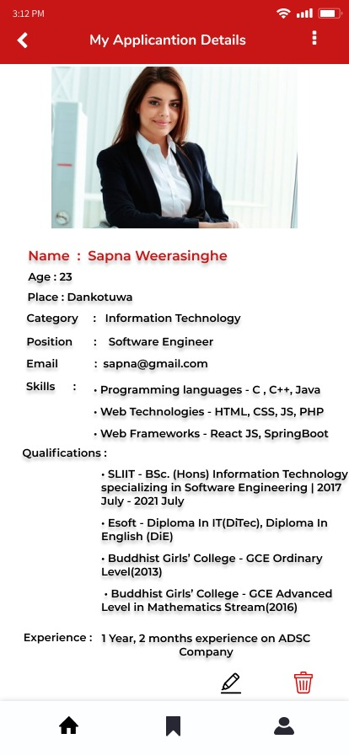 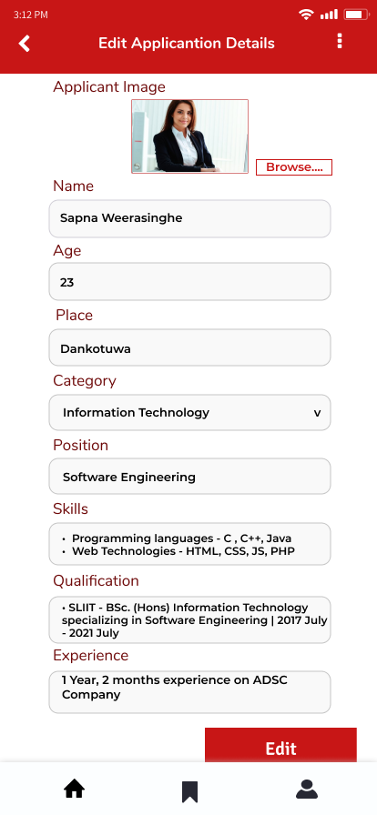 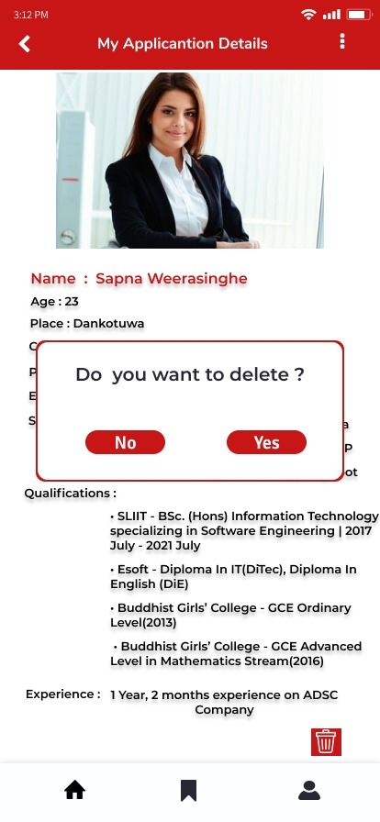

View Applicant Details Apply for job Favorite applicant details

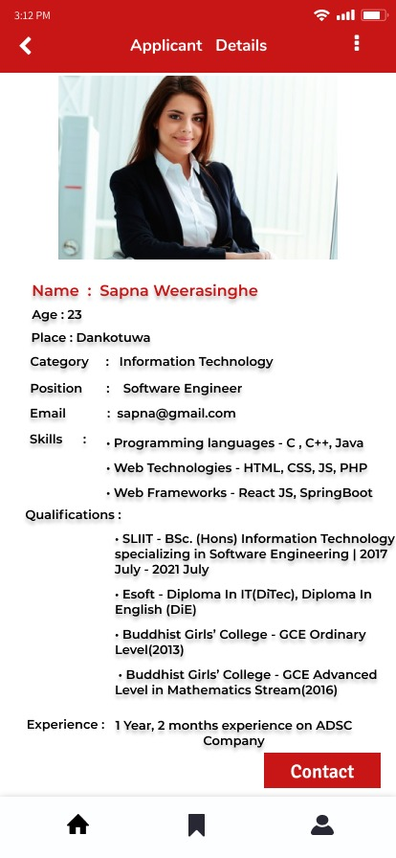 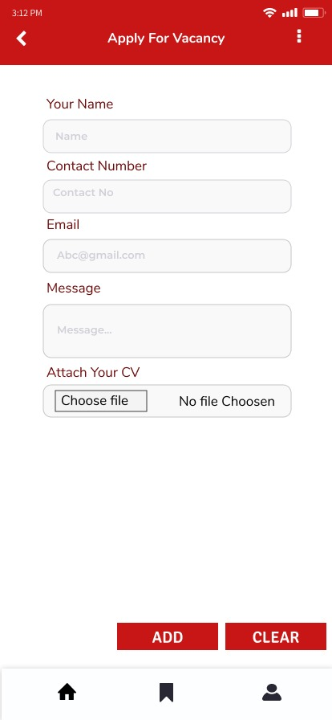 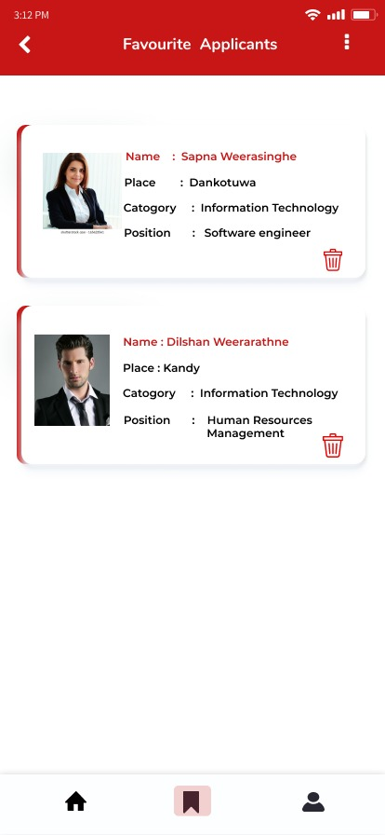

**Interview**

**<<Interview video link>>**

[**https://web.microsoftstream.com/video/fd0d2464-f5f4-4daf-81cf-7643ec5d6d95?list=studio**](https://web.microsoftstream.com/video/fd0d2464-f5f4-4daf-81cf-7643ec5d6d95?list=studio)

**Script 01**

[Welcome – Thanks – Introductions - Explanation of research team? Why we're testing our product.]

Q : Hello!

We are 3rd year undergraduate at SLIIT. These days we are researching about the Topjobs app and for that we are doing a user testing research to check weather our application is more user-friendly, and functionalities are more efficient to the users. So, we invited an undergraduate who has used this app to discuss about her experiences and test the designing.

Hi! Abesinghe, welcome to our interview and thank you taking the time to participate in this study. Can you give us a brief introduction about you?

A: Hi I am ___________, I am currently working in interning ________, and I am an undergraduate in ________ Campus.

[Brief explanation about the testing.]

Q : Ok, as you know we selected Topjobs app as our project. Topjob app is used to access job vacancies on mobile devices. So, we plan to do a testing to confirm our designed interfaces and to know what the new features are we have to add to these new interfaces and to know what the differences are we have to do.

So, first I will give a brief explanation about this session. Before we begin, I am going to tell you how this will work. This session is pretty straightforward. I’ll be giving you a broad task to complete and then asking questions as we go along. Before I tell you the task, I’ll be giving you a little bit of context behind it, such as why you might be doing it and what you hope to achieve.

So, this is very important to know that we are only testing the application, not you. You can do or say anything wrong here and please feel free to let me know at any time if there’s something you like or dislike and if you’re confused let us know and I promise you won’t hurt my feelings.

Also, I’d like you to “think aloud” as much as possible. By that I mean that I’d like you to speak your thoughts as often as you can. For example, you may be looking at a page, suddenly see something you didn’t see before and want to click on it. In that case, saying something like “this caught my eye so I’m going to see what it is” would be very useful and something like that.

If at any point you have questions, please don’t hesitate to ask. Do you have any questions so far?

[First task testing]

Q : Ok let’s get started.

Task 01

* Manage user profile

A: First, I’ll give you our first task. This is the prototype designing that we have done for the Topjobs app. First task is managing profile.

User Flow

Select user type (as job seeker).

[ADD]

Register as job seeker.

Press Register button.

Sign in as registered job seeker.

A : In case if password is forgotten, I can click “Forgot password” button right?

Q : Yes, absolutely.

Go to profile page by clicking profile icon in right bottom corner.

[UPDATE]

Go to edit details page by clicking “Edit user details” button.

Edit all the required fields and press “EDIT” button.

A: I can change my password in here also, right?

Q : Yes, you can change your password by clicking “Change password” button.

[DELETE]

Press “LOG OUT’ button to log out.

Log in again to the system.

Press “DELETE ACCOUNT” button to log out.

Task 02

* Manage applicant details.

User Flow

* Select user type as job seeker.
* Sign into the system.
* Navigate to the home page.

[ADD]

* Click “Add Applicant Details” button.
* All applicants will be displayed in the interface.
* Click “+” icon in bottom right corner to add new applicant.
* After filling all the details, click “ADD” button.

[UPDATE]

* Go to the profile page by clicking profile icon.
* Click “Edit applicant details” button to edit details.
* All the added details will be displayed.
* Details can be edited by clicking on edit icon at the bottom.
* After editing all required fields, click “EDIT” button.

[DELETE]

* Click on delete icon to delete the applicant.
* A dialog box will be displayed.
* Click on “Yes” button to delete applicant.

[Apply for job vacancy]

* Navigate to the home page.
* Click “Job Vacancies” button.
* Select a required job category.
* All job vacancies will be displayed and select a job vacancy and click on it.
* All the details required to that vacancy, will be displayed.
* Click on “Apply Now” button at bottom to apply for that vacancy.
* Fill all fields and upload CV and click on “ADD” button.

[RETRIEVE]

User can save job vacancies by clicking on save icon at top right corner in job vacancies.

Saved job vacancies can be viewed by clicking save icon and all saved vacancies will be visible and, saved vacancies can be deleted by clicking on delete icon in vacancies.

User comments and suggestions

* Skip on board pages.
* All the buttons should be in middle.
* All the buttons should be round, and it will make interfaces more user-friendly.
* All the interfaces are very attractive and nicer than the original Topjobs app.
* All the required features and functionalities (Log in, Register, apply for vacancies) which were not in the original Topjobs app are included here, it makes users so comfortable.

[Thanks for coming to the interview]

**Script 02**

[Welcome]

Hello ____________, Good evening. Welcome to our interview and thank you taking the time to participate in this study.

Q : Can you tell me about yourself?

A : My name is ______ . I am currently working _____ company as a software engineer.

[Explanation of research team and why we are testing]

We did research about the topjobs app and now we are going to develop that app with new features.

We have created prototype of user interfaces of the application which we going to develop, and now we are going to test our app with you, and we need to get a brief idea regarding the user friendliness, user flow, colors , design of this app.

Q : Do you have use top job application before ?

A: Yes

[Explain the session]

Before we begin, I’m going to give you a brief overview of the test and how it will work.

I’ll be giving you a broad task to complete and then asking questions as we go along.  Before I tell you the task, I’ll be giving you a little bit of context behind it, such as why you might be doing it and what you hope to achieve.

It’s really important to know that we are only testing the application, not you. If you cannot complete a task do not think about it and you can tell me . Please feel free to let me know at any time if there’s something you like, dislike, if you’re confused, etc. I promise you won’t hurt my feelings.  
  
please speak while you are doing a task.   
  
If at any point you have questions, please don’t hesitate to ask.

Do you have any questions so far?

Shall we start the first task

**Task 01**

* Add a new job vacancy to this app and manage added job vacancy (Update , delete)

User flow :

* Select the type of user. ( As a job provider)
* Sign-up to the system
* Navigate to the home page and click the add job vacancy button.
* Then display all the added job details and click on the “+” button and navigate to the post a job vacancy page.
* Fill all the details and click on the “POST” button.

[update]

* Click on the update icon and then navigate to the update job vacancy page.
* Fill all the required fields and click in the “UPDATE” button.

[Delete]

* Click on the delete icon and then navigate to the delete job vacancy page.
* Then click on the “DELETE” button.

User comments and suggestions.

* Color and design of the application is good.
* Add reset button to the add job vacancy page and edit job vacancy page.
* Round the border of the buttons.
* Remove the delete page and put an alert message box instead of the delete page.

Q : What do you think about the user flow of this app?

A : Easy to complete a task. Every user can easily understand the way of the user flow.

**Task 02**

* Find a candidate and view candidate’s details.

User flow

* Sign- In to the system.
* Navigate to the home and click on the “View Candidate” button.
* Go through the list of the candidate’s page.
* Click on selected candidate.
* Then navigate to the page which displays all the details of required candidate.

User comments and suggestions.

* Color and design of the application is good.
* Esay to navigate through this app.

[Thank you for doing tasks]

Q : Do you have any suggestions or comments about this application

A : This app is better than previous app. and if you can make buttons rounded it is good and it is my preference

Colors and features are good. App performance designs all the things are good.

[Thanks for coming to the interview]

**Version 02**

**Confirmed** **Sketches, Wireframes and Paper prototypes**

**Submission Template**

Loading Page On boding page 01 On boding page 02

  

On boding page 03 Home (Job Provider) Home (Job Seeker)

  

**User Management and Profile** ( IT19176116 - T. M. L Bambarandage)

|  |  |  |
| --- | --- | --- |
| **Landing Page** | | |
|  |  |  |

|  |  |  |
| --- | --- | --- |
| **Job Provider Sign in Page** | | |
|  |  |  |
| **Job Seeker Sing in Page** | | |
|  |  |  |

|  |  |  |
| --- | --- | --- |
| **Create an account Page(Job Provider)** | | |
|  |  |  |
| **Create an account Page(Job Seeker)** | | |
|  |  |  |

|  |  |  |
| --- | --- | --- |
| **Sign in Page(Job provider)** | | |
|  |  |  |
| **Sign in Page(Job Seeker)** | | |
|  |  |  |

|  |  |  |
| --- | --- | --- |
| **Profile (Job Provider)** | | |
|  |  |  |
| **Profile (Job Seeker)** | | |
|  |  |  |

|  |  |  |
| --- | --- | --- |
| **Edit Profile (Job Provider)** | | |
|  |  |  |
| **Edit Profile (Job Seeker)** | | |
|  |  |  |

|  |  |  |
| --- | --- | --- |
| **Change Password Page** | | |
|  |  |  |
| **Forgot Password Page** | | |
|  |  |  |

|  |  |  |
| --- | --- | --- |
| **Reset password Page** | | |
|  |  |  |

**Post job vacancies.** ( IT19382036 - L.S Gamage )

|  |  |  |
| --- | --- | --- |
| **Job Categories** | | |
|  |  |  |
| **View Job Vacancies (Job Seekers)** | | |
|  |  |  |

|  |  |  |
| --- | --- | --- |
| **Job Vacancies (Job Provider)** | | |
|  |  |  |
| **Post New Job Vacancy Page** | | |
|  |  |  |

|  |  |  |
| --- | --- | --- |
| **Edit Job Vacancy Page** | | |
|  |  |  |
| **Delete Job Vacancy Page** | | |
|  |  |  |

|  |  |  |
| --- | --- | --- |
| **View Job Vacancy Details** | | |
|  |  |  |
| **Job Favorite List** | | |
|  |  |  |

**Manage candidate details and apply for jobs.** (IT19989242 - Anjali W. M. S)

|  |  |  |
| --- | --- | --- |
| **View All Applicants (job Providers)** | | |
|  |  |  |
| **View All Applicants (job Seekers)** | | |
|  |  |  |

|  |  |  |
| --- | --- | --- |
| **Add Applicant Details** | | |
|  |  |  |
| **View Applicant Details (Job Provider)** | | |
|  |  |  |

|  |  |  |
| --- | --- | --- |
| **View Applicant Details (Job Seeker)** | | |
|  |  |  |
| **Delete Applicant Details** | | |
|  |  |  |

|  |  |  |
| --- | --- | --- |
| **Edit Applicant Details Page** | | |
|  |  |  |
| **Favorite List** | | |
|  |  |  |

|  |  |  |
| --- | --- | --- |
| **Apply For Job Vacancy** | | |
|  |  |  |

User Flow of the application



|  |  |  |
| --- | --- | --- |
| Student ID | Student Name | Function and contribution |
| IT19382036 | L.S Gamage | Post job vacancies. -  Version 01 prototypes  Version 02 prototypes and wire frame designs |
| IT19176116 | T. M. L Bambarandage | User Management and Profile –  Version 01 prototypes  Version 02 prototypes and wire frame designs |
| IT19989242 | Anjali W. M. S | Manage candidate details and apply for jobs. –  Version 01 prototypes  Version 02 prototypes and wire frame designs |